Latent phenotypic complexity of adaptation in a single environment

**INTRODUCTION** [Not yet changed from Kerry’s original]

# **Paragraph One: Adaptation is awesome, but it shouldn’t be.**

# Single punchy (less technical) sentence that captures main idea of paper:

# Organisms have an amazing ability to adapt to diverse challenges, yet recent observations suggest most mutations affect many traits and most of these effects are deleterious. How is adaptation possible if mutants that influence one trait in a beneficial way influence many other traits in a deleterious way?

* 1. We know it is indeed possible: examples of adaptation’s awesome power
     1. Ben Good showing that microbes never run out of adaptive mutations
     2. Which other examples?
  2. But how is adaptation possible? Conclude by defining the ‘cost of pleiotropy’ and explaining that the more pleiotropy there is, the greater the constraint on adaptation.

1. **Section Two: How much pleiotropy is there and why is it so hard to find out?**
   1. Long history of debate on this topic.
      1. Is pleiotropy omnigenic/universal or modular? If modular, by learning relationships among traits one might be able to predict which suites of traits are jointly influenced by genetic changes.
      2. Though modularity seems reasonable and many studies suggest cellular systems have a modular organization, GWAS studies detect ungodly amounts of pleiotropy suggesting every gene has the potential to influence every trait.
   2. This debate persists because of challenges defining and measuring phenotypes, and integrating information about phenotypes at different levels of biological organization
      1. There are too many phenotypes, potentially millions or an infinite number depending on how creative you are
      2. Phenotypes are often related, effects cascading through levels of biological organization, introduce genotype-phenotype-phenotype map idea
   3. Conclude by explaining the ‘impossible task’: Quantifying all of these traits and enumerating relationships between them to understand which suites of traits (or whether every trait) will be jointly influenced by a mutation is too much work.
2. **Section three: Clever solutions leveraging barcoding**
   1. We have a new approach to understanding the extent of pleiotropy among adaptive mutations that circumvents the problem. We do not measure any of these phenotypes, instead we repeatedly measure fitness.
   2. Briefly explain the idea in general terms, subtle perturbations, FGM
   3. Explain the large data set we will use to test the idea, and how this is only possible because (1) these strains are barcoded, (2) NGS gives us lots of power to measure fitness, and (3) we cleverly use information about fitness to learn something about phenotypes.
3. **Section four: What do we find? Punchlines**
   1. The number of ‘traits’ affected by an adaptive mutation depends on context
      1. Adaptive mutations influence a limited number of ‘traits’ in environments close to the one in which they are adaptive.
      2. As we perturb the environment farther from this one, we reveal additional pleiotropic effects of adaptive mutations
      3. This suggests resolution to the paradox, how pleiotropy can be pervasive and adaptation can still happen
   2. Our method is really cool.
      1. Talk about all the cool things you could learn using this epic approach.

**RESULTS**

**Section 1: A method to identify fitness-relevant phenotypes**

1. Intuition: organism’s phenotype determines its interactions with environment and thus fitness. So by measuring fitness in different environments, we can learn about these interactions at start getting towards the important phenotypes
   1. Solidify this intuition with explicit discussion of SVD model.
   2. Identifying the complexity of phenotypes is difficult and involves selecting the proper model. This overfitting issue is a common statistical problem.
2. In simulation, we can identify phenotypic components using two procedures:
   1. Bi-cross-validation (talk about the procedure)
   2. Simulating noise matrix and doing SVD on this
3. Identifying fitness-relevant phenotypes relies on measurement precision, with more precision, you can detect more smaller signals.
4. Hint at latency stuff/idea

**Figure 1. [TBD]** Intuition for the SVD method, noise vs. signal, cross-validation procedure, simulations showing it works, building intuition for “latent phenotypes” [probably some supplemental figures to accompany]

**Section 2: Barcodes allow us to measure and detect differences between subtle environmental perturbations**

1. Mutants from the evolution experiment. Most are from nutrient-response pathways and/or diploidy.
   1. RAS/PKA mutants – are they adaptive for the same reason? do they exhibit the same phenotype in the evolutionary condition?
2. Barcodes allow us to measure the fitness of these mutants in a large collection of environments. We’re particularly interested in subtle environments, but it’s not clear what that is.
3. Barcodes let us measure fitness remarkably well.
   1. IRA1 spike ins cluster in replicates, replicates are more similar than batches [Fig S1A]
   2. Despite this, there are batch effects! [Fig S1B]
4. This measurement precision allows us to see a lot of variation across our collection of environments – some are subtle and some very much not subtle [Fig 2]
   1. Lots of possible signal here to learn about phenotypes!
   2. From fitness alone, it’s clear that fitness isn’t the whole story – there must be additional features that are important to the data. [some examples…]
   3. It’s also clear from the strong perturbations that particular mutants have different effects that aren’t obvious in M3 [GPB2, PDE2] – is this also true when we look at their behavior in the subtle perturbations?



**Figure 2. Measuring fitness for a collection of adaptive mutants across many environments has the potential to reveal real biological signal. (A)** Conditions are ordered based on similarity to the average across all batches. Conditions where the balanced recurrent mutations are less than two standard deviations different from the evolved condition are denoted in black and make up the subtle perturbation set. Conditions where the aggregate behavior exceeds two standard deviations are shown in red and make up the strong perturbations. **(B)** For each mutation type, we take the average fitness across the evolution condition batches and the standard deviation of this behavior –Shaded regions represent two standard deviations away from the mean amongst the batch conditions per mutation type. On the right are kernel density estimates for the distribution of each mutation type across all conditions (two standard deviations around batches are shaded).

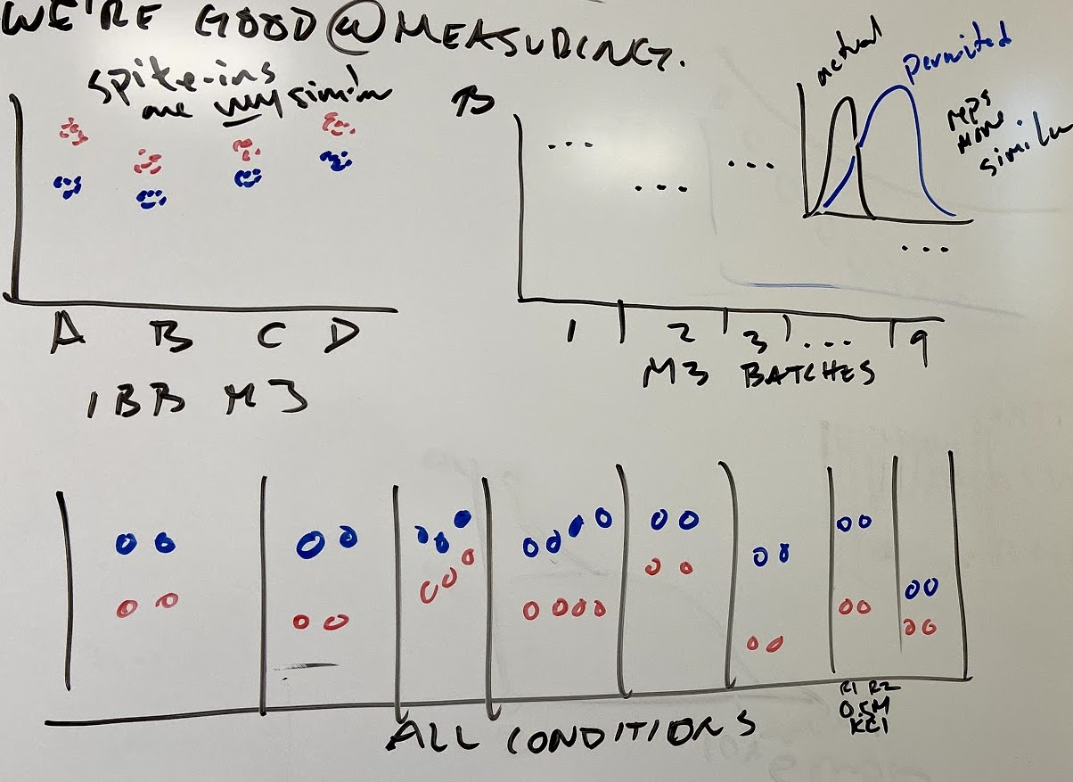

**Fig S1. We’re good at measuring things. (A)** Very little variation within flask for spike-ins labeling the same mutation. **(B)** Replicates within the same batch are more similar to each other than batches. **(C)** Showing all the replicates for all the non-batch conditions.



**Fig S2. M3 fitness doesn’t explain all the signal.** The relationship between average fitness in M3 and fitness in the rest of the conditions. There are intricate patterns of relationship across these conditions, indicating that the evolution condition fitness is not the only determinant of fitness across these perturbations.

**Table 1. All mutants included.**Show number of mutants, including number included in canonical training and test sets.

**Table S1. All conditions.** Detailed account of all the conditions used. Include batch number/date done, glucose conc., extras conc, flask used.

**Section 3: Phenotypes relevant to subtle perturbations have predictive power in strong environmental perturbations.**

1. Using SVD and our approaches to identify the number of components, we detect 9 fitness-relevant phenotypes from our collection of mutants in subtle environmental perturbations.
   1. However, with only 4 of these components we explain 95% of variation. The additional 5 each contribute less than 1% to explanatory power.
2. From the space constructed with subtle perturbations, we can accurately predict fitness in the strong perturbations, indicating we are learning about real biological signals
   1. Note, as we saw from the data alone, a single component (which is highly correlated with mean fitness in M3) does poorly.
   2. With 4 components, we do a very good job for most conditions (baffle, 1.8%, benomyl, 7 day)
   3. The additional minor phenotypes have strong effects in particular conditions (1 day, suc/raf, 2.5%, 4day, 6day)



**Figure 3. 9-component model can accurately predict fitness of held-out mutants in strong conditions.** **(A)** Predictions from the 9-component model (red circle) are typically better than the 1-component mode (open circle) and the average of 1000 permutations (black line, each permutation shown in gray). The 4-component model (black dot) has similar predictive power for most conditions. However, particular conditions (1-, 4-, 5-, 6-Day, Baffle + 2.5% Glucose, and 1% Sucrose/Raffinose) gain significant predictive power from the additional 5 minor components. **(B)** These conditions have much larger added variance explained from the 7th, 8th, and 9th components than the subtle and the other strong conditions. **(C)** Comparison of predictions of the 1-, 4-, and 9- component models for all held-out mutations in Baffle + 1.8% Glucose,1 Day, 1% EtOH, Baffle + Benomyl, and 0.5M NaCl conditions. Note that ${\tilde{R}}^{2}$ less than zero indicates that the prediction is worse than using the mean fitness in that condition and that ${\tilde{R}}^{2}$ is weighted according to the number of each mutation type present in the held out data (see Methods for details). Points in **(C)** colored by the mutation type. For a full set of prediction comparisons see Supplement. Gray and white background in **(A)** for eye-guiding purposes only.



**Fig S3. We detect 9 components with subtle perturbations. (A)** SVD on noise-only matrix detects 9 components. **(B)** Bi-cross validation also detects 9 components. **(C)** Strong perturbations best predicted by 9 components. **(D)** Added Weighted VE in subtle and in strong perturbations for test mutants. Slight increase in contribution of component 4 over 3 and 8 over 7 for subtle perturbations is due to use of weighted variance explained rather than raw variance explained that SVD optimizes on.

**Fig S4. Robust to choice of mutants.**

**Fig S5. All 1-, 4-, 9- component comparisons by condition. (for all of them).**

**Section 4: Adaptive mutants have general, shared phenotypic responses, with specific, latent phenotypes**

There are latent phenotypes that have minor contributions in the local neighborhood of conditions near the evolution condition. These phenotypes have significant and specific contributions for some particular strong conditions (1-, 4-, 5-, 6- Day). What is driving this predictive power? Is this driven by a collective response of these mutants that suddenly matters to these environments? Is it driven by specific effects of particular mutants?

Before we can answer these questions, we must first put these questions in context. What mutants have similar (or different) phenotypic responses? We can visualize the 9 fitness-relevant phenotypes of these mutants using UMAP. Here, we see an apparent structure emerge. It appears that most mutants have similar phenotypic responses based on genotype. To test this explicitly, we can compare the pairwise distance of mutants based on the genes they have mutations in relative to the pairwise distance of randomly chosen genes [] …

Moreover, it appears also that Diploids (including adaptive diploids) seem to separate out from haploid mutants (). Interestingly, we can see biological patterns emerge beyond the effect of pathway, i.e. we can detect differences between mutants (GPB2 and PDE2) despite them being in the same pathway with similar fitness effects.

Using UMAP to visualize the data, a few specific questions emerge. It appears that genes appear to cluster together. Is this true? We can test this by looking at the pairwise distance between all mutants of this mutation type. Are they closer to each other in the space than randomly selected mutants? There are two separate questions:

1. What is the structure of this set of mutants? [UMAP-like figure]
   1. GPB2, PDE2, and Diploid mutants cluster closely (with themselves)
   2. Diploids vs haploids
   3. IRA1 nonsense is all over the place
   4. Examples of mutants that we thought were similar but look different (GPB2 + PDE2, IRA1?)
   5. Examples of mutants that we thought were different but look similar (RAS2 + IRA1 mis? )
2. Latent phenotypes are driven by particular environmental interactions of particular mutants
   1. GPB2 in 1 Day w/ component 7
   2. IRA1 non, 4 Day, 5 Day, 6 Day w/ component 9
   3. Diploid w/ Chr 11 Amp in 1,4,5,6 with both 7th and 9th components.

**Figure 4. Uncovering real biology from the space of interactions. (A)** UMAP showing mutants and their relationship [also UMAP with conditions?] **(B)** Haploids vs. Diploids, RAS/PKA vs TOR**. (C)** What mutants are helped by the additional minor components in the particular conditions. **(D)** These specific mutants have particular effects in the crucial components (that have large effect in the corresponding conditions. **(E)** We learned this extra behavior from particular conditions – [do these map onto Yuping’s components at all??]

**Fig S6. What genes have similar interactions?** Distance from centroid for GPB2, PDE2, Diploid (all closer than random genes). IRA1 not really any closer (at least after filtering for haploids?).

**Fig S7. The space – all pairs of components (mutants AND conditions).**

**Fig S8. Individual mutant improvement in interesting conditions with minor components.**

**Fig S9. Testing “specific latency” hypothesis – if we remove mutants utilizing this extra component, do we suddenly go back to 4 being good enough?**

**DISCUSSION [just some scattered ideas right now]**

*this approach is a “new tool” through which we can identify fitness-relevant behavior].*

*Some other possible applications:*

*perturbing ecological communities to identify functional classes of behavior and ecological interactions*

*??*

*Possibility of using this approach to* *identify causal lower-level molecular phenotypes (via RNA-seq data or other phenotypic data) ]*

*Evolving to multiple environments? More complex environments?*

*Epistasis? [i.e. how do PDE2/GPB2 double mutants fare in M3, close conditions?*

Precision of measurement makes this possible – with less precision, we wouldn’t detect these latent phenotypes.

Strong perturbations? Do we get a different “answer”? why is subtlety important??

**Fig S9. Measurement precision allows us to detect latent phenotypes.** If we simulate less precise measurements, we see that we only detect 2-4 anyways…

**Fig S10. Why subtle?** What does doing SVD on ALL conditions give us? Why is subtlety important?

**METHODS**

**REFERENCES**